

***HTML Essentials***

**Assignments**

|  |  |
| --- | --- |
| Document Code | 25e-BM/HR/HDCV/FSOFT |
| Version | 1.1 |
| Effective Date | 20/11/2012 |

**Hanoi, 04/2019**

RECORD OF CHANGES

|  |  |  |  |  |  |
| --- | --- | --- | --- | --- | --- |
| No | Effective Date | Change Description | Reason | Reviewer | Approver |
|  | 25/Jun/2018 | Create a new Lab | Create new | DieuNT1 | VinhNV |
|  | 01/May/2019 | Update Fsoft Template | Update | DieuNT1 | VinhNV |
|  |  |  |  |  |  |
|  |  |  |  |  |  |
|  |  |  |  |  |  |
|  |  |  |  |  |  |
|  |  |  |  |  |  |
|  |  |  |  |  |  |
|  |  |  |  |  |  |
|  |  |  |  |  |  |

Contents

Unit 3 – HTML Text 4

Objectives: 4

Project Structure 4

Problem 1: HTML text basics 1 4

Problem 2: HTML text basics 2 6

Problem 3: HTML text basics 3 7

|  |  |
| --- | --- |
|  | **CODE: HTML-E.M.A601**  **TYPE: Medium**  **LOC: N/A**  **DURATION: 60 MINUTES** |

# Unit 7 – HTML Form

Objectives:

* Understand the syntax of HTML Form: <form>, <label>, <input>

Project Structure

* You are given a zip file **HTML-E.M.A701.zip**
* Extract the zip file, there is folder called **HTML-E.M.A701** (this will be your top folder)

Problem:

You are working on a Survey Form, the finished output should look like figure below:

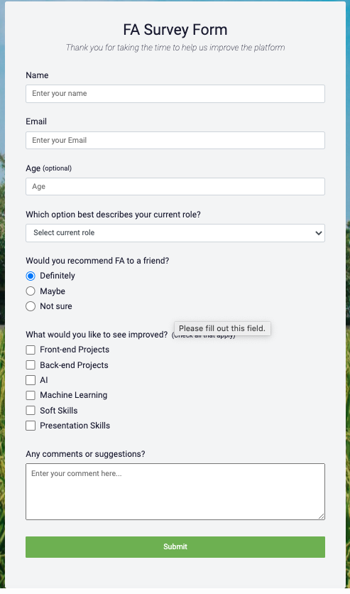

Hints and tips

* Each control must follow the structure like figure below: there is always a label associated with a input



1. <div class="form-group">
2. <label for="name">Name</label>
3. <input
4. type="text"
5. name="name"
6. id="name"
7. class="form-control"
8. placeholder="Enter your name"
9. required
10. />
11. </div>

* For <input> text, and <select> tags, you have to use **form-control** class
* For <input> radio, you have to use **input-radio** class
* For <input> checkbox, you have to use **input-checkbox** class
* For <textarean>, you must use **input-textarea** class
* For the submit button, you have to use **submit-button** class

**-- THE END --**